Project Planning Phase
Project Planning Template (Product Backlog, Sprint Planning, Stories, Story points)

Date | 01 July 2026
Team ID
Project Name | shopEZ-MERN E-commerce Application
Maximum Marks | 5 Marks

Product Backlog, Sprint Schedule, and Estimation (4 Marks)

Sprint | Functional Requirement (Epic) | User Story Number | User Story / Task | Story Points | Priority | Team Members
Sprint-1 | User Authentication | USN-1 | As a customer, I can register using my name, email, password, and role. | 3 | High | 1.Sri Sai Venkat  Barla  2.Sowmya Kodali  3.Sai Sreedevi Pulaparthi  4.Teomayee Hema Sridevi Geddada
Sprint-1 | user Authentication | USN-2 | As a customer, I can log in securely using email and password. | 2 | High
Sprint-1 | user Authentication | USN-3 | As a user, I can log out of my account securely. | 1 | Medium
Sprint-2 | Category Management | USN-4 | As an admin, I can create product categories. | 2 | Medium
Sprint-2 | category Management | USN-5 | As an admin, I can edit and delete categories. | 2 | Medium
Sprint-2 | Product Management | USN-6 | As a seller, I can add new products. | 2 | High
Sprint-2 | Product Management | USN-7 | As a seller, I can add new products and delete products,update products information | 5 | High
Sprint-3 | Product Browsing | USN-8 | As a customer, I can browse all available products. | 2 | High
Sprint-3 | Product Browsing | USN-9 | As a customer, I can search products by keyword,filter by category and price. | 3 | Medium
Sprint-4 | Shopping Cart | USN-10 | As a customer, I can add products to my cart and remove products from cart. | 3 | Medium
Sprint-4 | Shopping Cart | USN-11 | As a customer, I can update cart quantity. | 2 | Medium
Sprint-4 | Wishlist | USN-12 | As a customer, I can add products to my wishlist and remove products from wishlist | 2 | High
Sprint-5 | Order Management | USN-13 | As a customer, I can place an order using Buy Now and also from cart | 5 | High
Sprint-5 | Order Management | USN-14 | As a customer, I can view my order history. | 3 | Medium
Sprint-6 | Admin Dashboard | USN-15 | As an admin, I can view all registered users. | 2 | Medium
Sprint-6 | Admin Dashboard | USN-16 | As an admin, I can manage products. | 3 | High
Sprint-6 | Admin Dashboard | USN-17 | As an admin, I can update order status. | 3 | High
Sprint-6 | Reports | USN-18 | As an admin, I can view sales reports and analytics | 4 | Medium

Project Tracker, Velocity & Burndown Chart: (4 Marks)
Sprint | Total Story Points | Duration | Sprint Start Date | Sprint End Date (Planned) | Story Points Completed (as on Planned End Date) | Sprint Release Date (Actual)
Sprint-1 | 6 | 2 Days | 01 July 2026 | 02 July 2026 | 6 | 02 July 2026
Sprint-2 | 9 | 2 Days | 03 July 2026 | 04 July 2026 | 9 | 04 July 2026
Sprint-3 | 5 | 2 Days | 05 July 2026 | 06 July 2026 | 5 | 06 July 2026
Sprint-4 | 7 | 2 Days | 07 July 2026 | 08 July 2026 | 7 | 08 July 2026
Sprint-5 | 8 | 2 Days | 09 July 2026 | 10 July 2026 | 8 | 10 July 2026
Sprint-6 | 12 | 4 Days | 10 July 2026 | 13 July 2026 | 12 | 13 July 2026

Velocity:
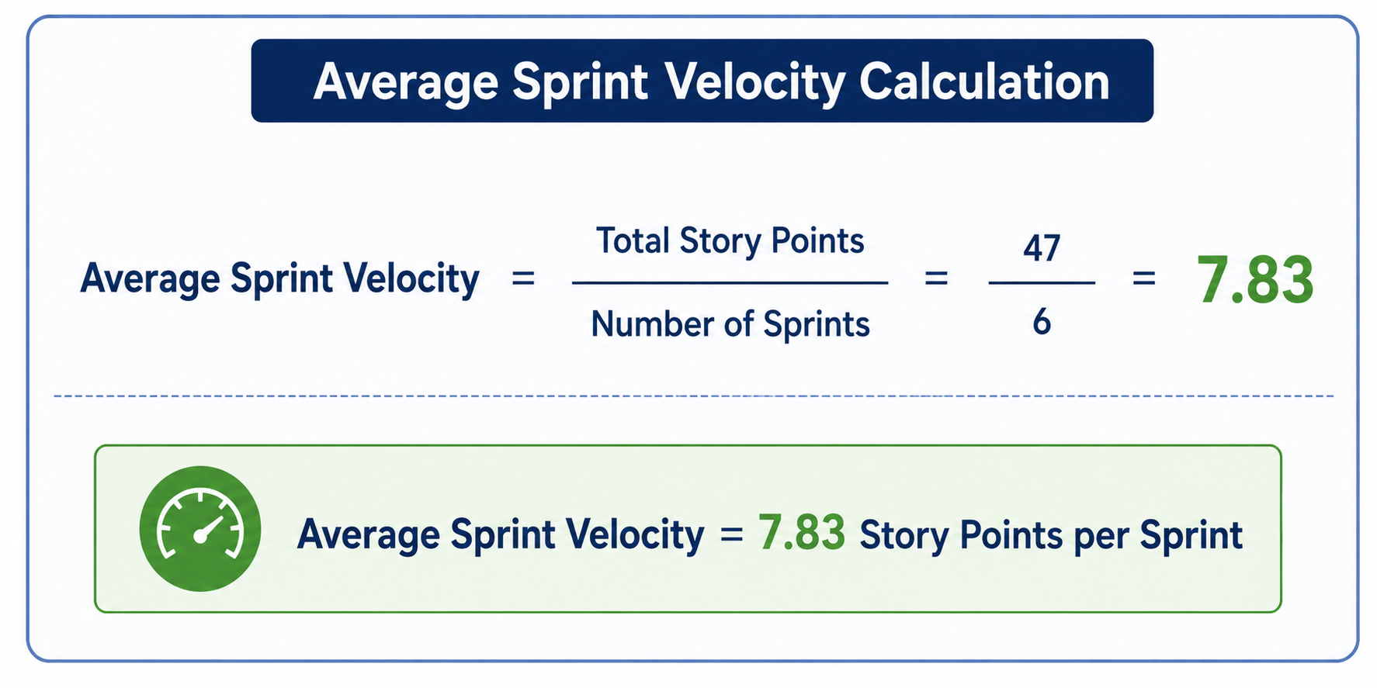
Burndown Chart:
